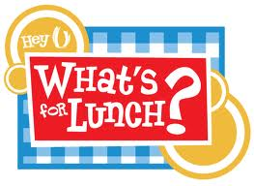
Monday 9/19: Ham and Cheese on Wheat with Sweet Potato Fries
Berries
Milk/Water

Tuesday 9/20: Breaded Fish with mixed Vegetables
Peaches
Milk/Water

Wednesday 9/21: Chicken Salad on Croissant with
Green Beans & Almonds
Cantaloupe
Milk/Water

Thursday 9/22: Beef Stew
Bananas
Milk/Water

Friday 9/23: Spaghetti & Meatballs
Applesauce
Milk/Water

