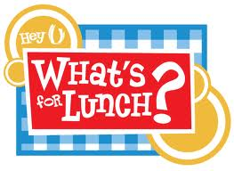
Chicken Alfredo with
Pasta and Spinach
Peaches
Milk/Water

Hot Roast Beef with Gravy
Mashed Potatoes
Green Beans
Berries
Milk/Water

Pasta & Ground Beef in
Tomato Sauce
Mixed Fruit
Milk/Water

Broccoli Quiche
Shredded Slaw
Pears
Milk/Water

Pizza
Applesauce
Milk/Water

Monday 12/5:

Tuesday 12/6:

Wednesday 12/7:

Thursday 12/8:

Friday 12/9:

